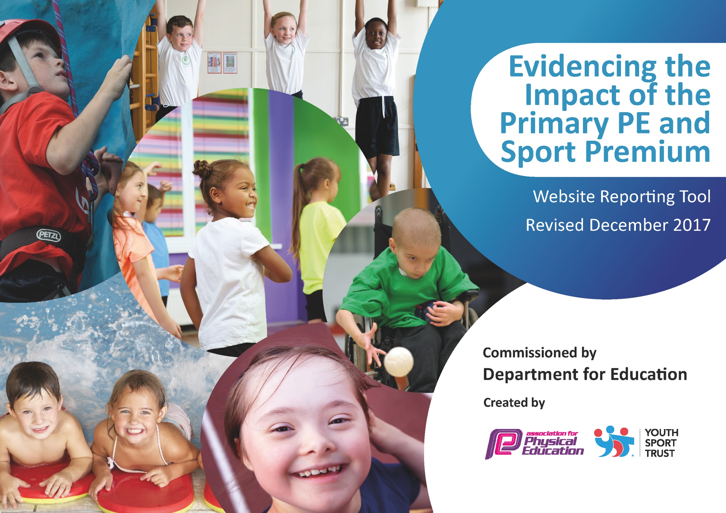

Schools must use the funding to make additional and sustainable improvements to the quality of PE and sport they offer. This means that you should use the Primary PE and Sport Premium to:

- develop or add to the PE and sport activities that your school already offers
- build capacity and capability within the school to ensure that improvements made now will benefit pupils joining the school in future years

Please visit gov.uk for the revised DfE guidance including the 5 key indicators across which schools should demonstrate an improvement. This document will help you to review your provision and to report your spend. DfE encourages schools to use this template as an effective way of meeting the reporting requirements of the Primary PE and Sport Premium.

We recommend you start by reflecting on the impact of current provision and reviewing the previous spend.
Under the Ofsted Schools Inspection Framework, inspectors will assess how effectively leaders use
the Primary PE and Sport Premium and measure its impact on outcomes for pupils, and how effectively governors hold them to account
for this.

Schools are required to publish details of how they spend this funding as well as on the impact it has on pupils’ PE
and sport participation and attainment.
We recommend regularly updating the table and
publishing it on your website as evidence
of your ongoing review into how you are using the money
to secure maximum, sustainable impact. To see an example of how to complete the table please click HERE.

Support for review and reflection - considering the 5 key indicators from DfE, what development needs are a priority for your setting and your students now and why? Use the space below to reflect on previous spend, identify current need and priorities for the future.

Key achievements to date: | Areas for further improvement and baseline evidence of need:
- Children to have further opportunities to have a go at new/challenging sports
- Provide more opportunities for collaborative participation at sporting events
- Further develop subject knowledge of staff
- Children to have the opportunity to swim every week as many children that come to us at Springwell have never had swimming lessons or not been allowed to go swimming with school due to their behaviour

Meeting national curriculum requirements for swimming and water safety | Please complete all of the below*:
What percentage of your current Year 6 cohort swim competently, confidently and proficiently over a distance of at least 25 metres? | 33%
What percentage of your current Year 6 cohort use a range of strokes effectively [for example, front crawl, backstroke and breaststroke]? | 33%
What percentage of your current Year 6 cohort perform safe self-rescue in different water-based situations? | 33%
Schools can choose to use the Primary PE and Sport Premium to provide additional provision for swimming but this must be for activity over and above the national curriculum requirements. Have you used it in this way? | Yes
*Schools may wish to provide this information in April, just before the publication deadline.

Action Plan and Budget Tracking
Capture your intended annual spend against the 5 key indicators. Clarify the success criteria and evidence of impact that you intend to measure to evaluate for students today and for the future.

Academic Year: 2017/18 | Total fund allocated: £14182 | Date Updated:
Key indicator 1: The engagement of all pupils in regular physical activity – Chief Medical Officer guidelines recommend that primary school children undertake at least 30 minutes of physical activity a day in school |  |  |  | Percentage of total allocation:
 |  |  |  | 41%
School focus with clarity on intended impact on pupils: | Actions to achieve: | Funding allocated: | Evidence and impact: | Sustainability and suggested next steps:
- Children in Y1-6 will have daily access to morning ‘get active’ activity as part of 30 mins activity  - Children to develop fine and gross motor skills through structured activity time  - All children to learn about the importance of exercise and healthy lifestyles through PSHE linked activities  - Children to have access to regular swimming lessons all year round | - Subscription to online get active programme  - Purchase of bikes, scooter, helmets, bats and balls  - PSHE sessions to raise awareness of healthy lifestyles choices using ‘change for life’  - Swimming lessons to be booked and progress of children tracked | £265  £2,300  £0  £3,500 | Improved behaviour…  RPIs for 1st term 2017/18 in primary were 2705 this reduced to 536 in the final term. Primary attendance increased from 85% (2016-17) to 89% (2017-18).  Improved behaviour…  RPIs for 1st term 2017/18 in primary at or after lunch were 1277 this reduced to 262 in the final term.  Improvement from 0% to 33% of year 6 children able to swim competently and self rescue | Swimming will continue to be a priority for new yr6 cohort. As will ‘get active’ sessions + PE + structured activities at break and lunch.  Physical resources such as bikes and scooters are in place but will require repair / replacements throughout the year.
Key indicator 2: The profile of PE and sport being raised across the school as a tool for whole school improvement |  |  |  | Percentage of total allocation:
 |  |  |  | 3%
School focus with clarity on intended impact on pupils: | Actions to achieve: | Funding allocated: | Evidence and impact: | Sustainability and suggested next steps:
- Children will have the opportunity to be involved in collaborative sport and inter centre events and competitions.  - Children will have increased opportunities to play sports and team games against other children and a wider range of peers.  - Children will have sporting success’ celebrated at school.  - Children will take part in timetabled charity events involving being active. | - Tournaments across centres or other schools within the trust - football, cricket, rounders  - Achiever assemblies to include inside and outside sporting achievements.  - Centres to plan sponsored activities which encourage children to get active | Centre competitions (staff cover and transport)  £400 | Not achieved due to other school improvement priorities.  Wide range of sporting activites inc, badminton, tennis, uni hockey, Danish long ball, climbing, swimming, kayaking, football, dodgeball and gym sessions  Examples of ‘active sponsored events’ include litter picking and Mablethorpe in Bloom project.  Improved behaviour…  RPIs for 1st term 2017/18 in primary were 2705 this reduced to 536 in the final term.  Primary attendance increased from 85% (2016-17) to 89% (2017-18). | Inter centre competitions planned for 2018/19  To continue to develop a range of activities  To continue to take part in active sponsored events

Key indicator 3: Increased confidence, knowledge and skills of all staff in teaching PE and sport |  |  |  | Percentage of total allocation:
 |  |  |  | 4%
School focus with clarity on intended  impact on pupils: | Actions to achieve: | Funding  allocated: | Evidence and impact: | Sustainability and suggested  next steps:
- Children will have swimming lessons taught by experienced swimming instructors  - Staff will develop knowledge and confidence in the delivery of PE lessons | - Employ experienced swim instructors in addition to swimming lessons  - Source additional training schemes/resources for staff | See above  £ 500 | Improvement from 0% to 33% of year 6 children able to swim competently and self rescue  Ongoing as this will take time to embed | Ongoing for new cohort  Ongoing – especially for new staff
Key indicator 4: Broader experience of a range of sports and activities offered to all pupils |  |  |  | Percentage of total allocation:
 |  |  |  | 49%
School focus with clarity on intended  impact on pupils: | Actions to achieve: | Funding  allocated: | Evidence and impact: | Sustainability and suggested  next steps:
- Children will experience new and challenging sporting activities.  - Children will experience a more varied spectrum of sports- encouraging them to consider taking up new/different sports within and outside of school. | - Book a range of off site local sport activities such as parkour, trampolining and climbing  - Promote different sports through fliers and talking about different sports through sharing news | £7,000  £0 | Wide range of sporting activites inc, badminton, tennis, uni hockey, Danish long ball, climbing, swimming, kayaking, parkour, football, dodgeball and gym sessions  Primary attendance increased from 85% (2016-17) to 89% (2017-18). | Continue to develop a range of activities . Maintain links with outside providers.
Key indicator 5: Increased participation in competitive sport |  |  |  | Percentage of total allocation:
 |  |  |  | 3%
School focus with clarity on intended  impact on pupils: | Actions to achieve: | Funding  allocated: | Evidence and impact: | Sustainability and suggested  next steps:
Children will have the opportunity to be involved in inter centre competitions and centre sports challenges. | - Tournaments across centres or other schools within the trust - football, cricket, rounders  - Centre based sports events and challenges | Travel costs  £200  Equipment  £300 | Sporting equipment has been purchased  Clubs have been set up  Wide range of sporting activites inc, badminton, tennis, uni hockey, Danish long ball, climbing, swimming, kayaking, parkour, football, dodgeball and gym sessions  Primary attendance increased from 85% (2016-17) to 89% (2017-18). | Ongoing to facilitate inter-centre competitions.

